C. U. Shah College of Engineering & Technology
Surendranagar – Ahmedabad Highway, Near Kotharia Village
Wadhwan City – 363 030.

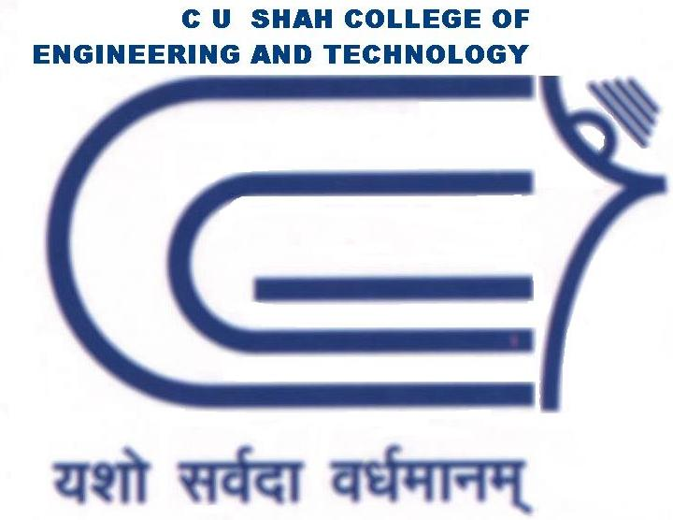

CERTIFICATE

T O W H O M S O E V E R I T M A Y C O N C E R N
This is to certify that Mr. RAJA BISWAS of B. E. Semester VIII (Information Technology) has completed his project work titled “ STUDENT MANAGEMENT SYSTEM – AN EXTENSION TO HMIS ” satisfactorily in partial fulfillment of requirement of Bachelor of Engineering degree course, Saurashtra University, Rajkot, in the year 2010-2011.
Internal Project Guide:
Mr. Rahul Joshi Dr. K. H. Wandra
(Analysis Guide) (Vice-Principal & HOD CE / IT Dept)

Mr. Devendra Thakor
(Technical Guide)

External Project Guide:
Mr. Dhaval Patel
(Business Associate, TCS Gandhinagar)

